Lesson 7: Creating Interactive Dashboards and Data Stories
a) Design a basic dashboard layout using sheets
b) Add filters and interactive controls
c) Implement highlight and filter actions
d) Use URL and set actions for interactivity
e) Create dynamic dashboards using parameters
f) Design dashboards for multiple devices
g) Build a complete data story using Story feature

Before we begin building sheets for the layout in Part A:
1. Open Tableau Desktop.
2. Connect to matches.csv as your primary data source (or link matches.csv to deliveries.csv on id = match_id if using combined fields).
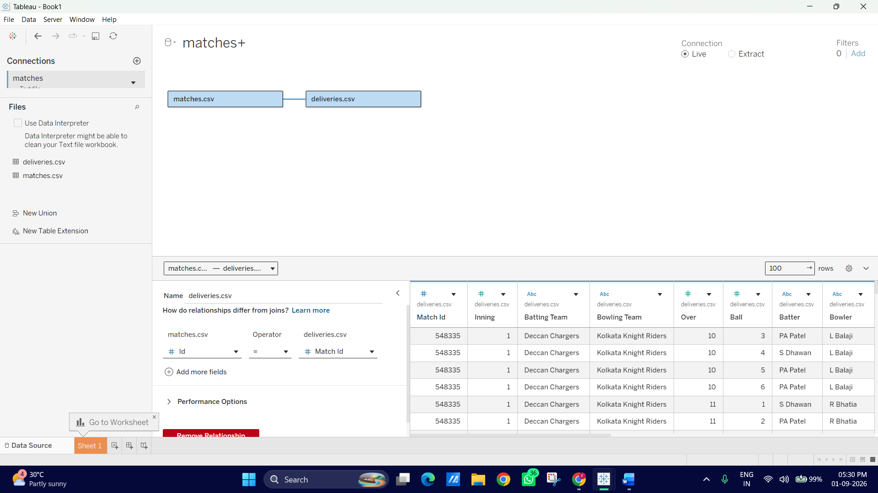

A: Design a basic dashboard layout using sheets
In this part, we will build 3 individual worksheets in Tableau using your matches.csv dataset, and then assemble them into a structured, tiled dashboard layout using containers.
Step 1: Create Sheet 1 — "Match Winners by Team" (Bar Chart)
1. Open a new worksheet and rename it: Matches Won by Team.
2. Drag Winner from Dimensions to the Rows shelf.
- Quick Filter: Drag Winner to the Filters shelf and uncheck Null (to clear matches with no result/abandoned).
3. Drag Matches (Count) (or Id using measure CNTD) to the Columns shelf.
4. Click Sort Descending on the top toolbar so the team with the most wins (e.g., Mumbai Indians) appears at the top.
5. Drag Winner to Color on the Marks card to give each team its distinct color.
6. Click Label on the Marks card ◊ Check Show mark labels.
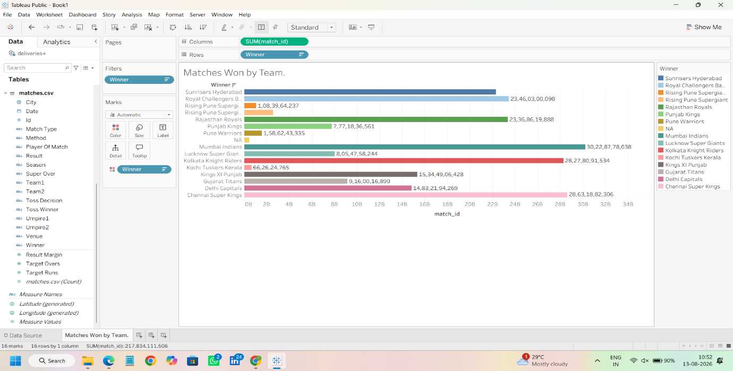

Step 2: Create Sheet 2 — "Top Match Venues" (Horizontal Bar Chart)
1. Open a new worksheet and rename it: Top Venues.
2. Drag Venue to the Rows shelf.
3. Drag Matches (Count) (or Id using CNTD) to the Columns shelf.
4. Sort in Descending order (Left Click on Venue on The Rows and Navigate to Sort).
5. Drag Venue to the Filters shelf, go to the Top tab ◊select By field ◊ Top 10 by Matches (Count).
6. Change the mark type on the Marks card to Bar and color it a neutral shade (e.g., Navy Blue).
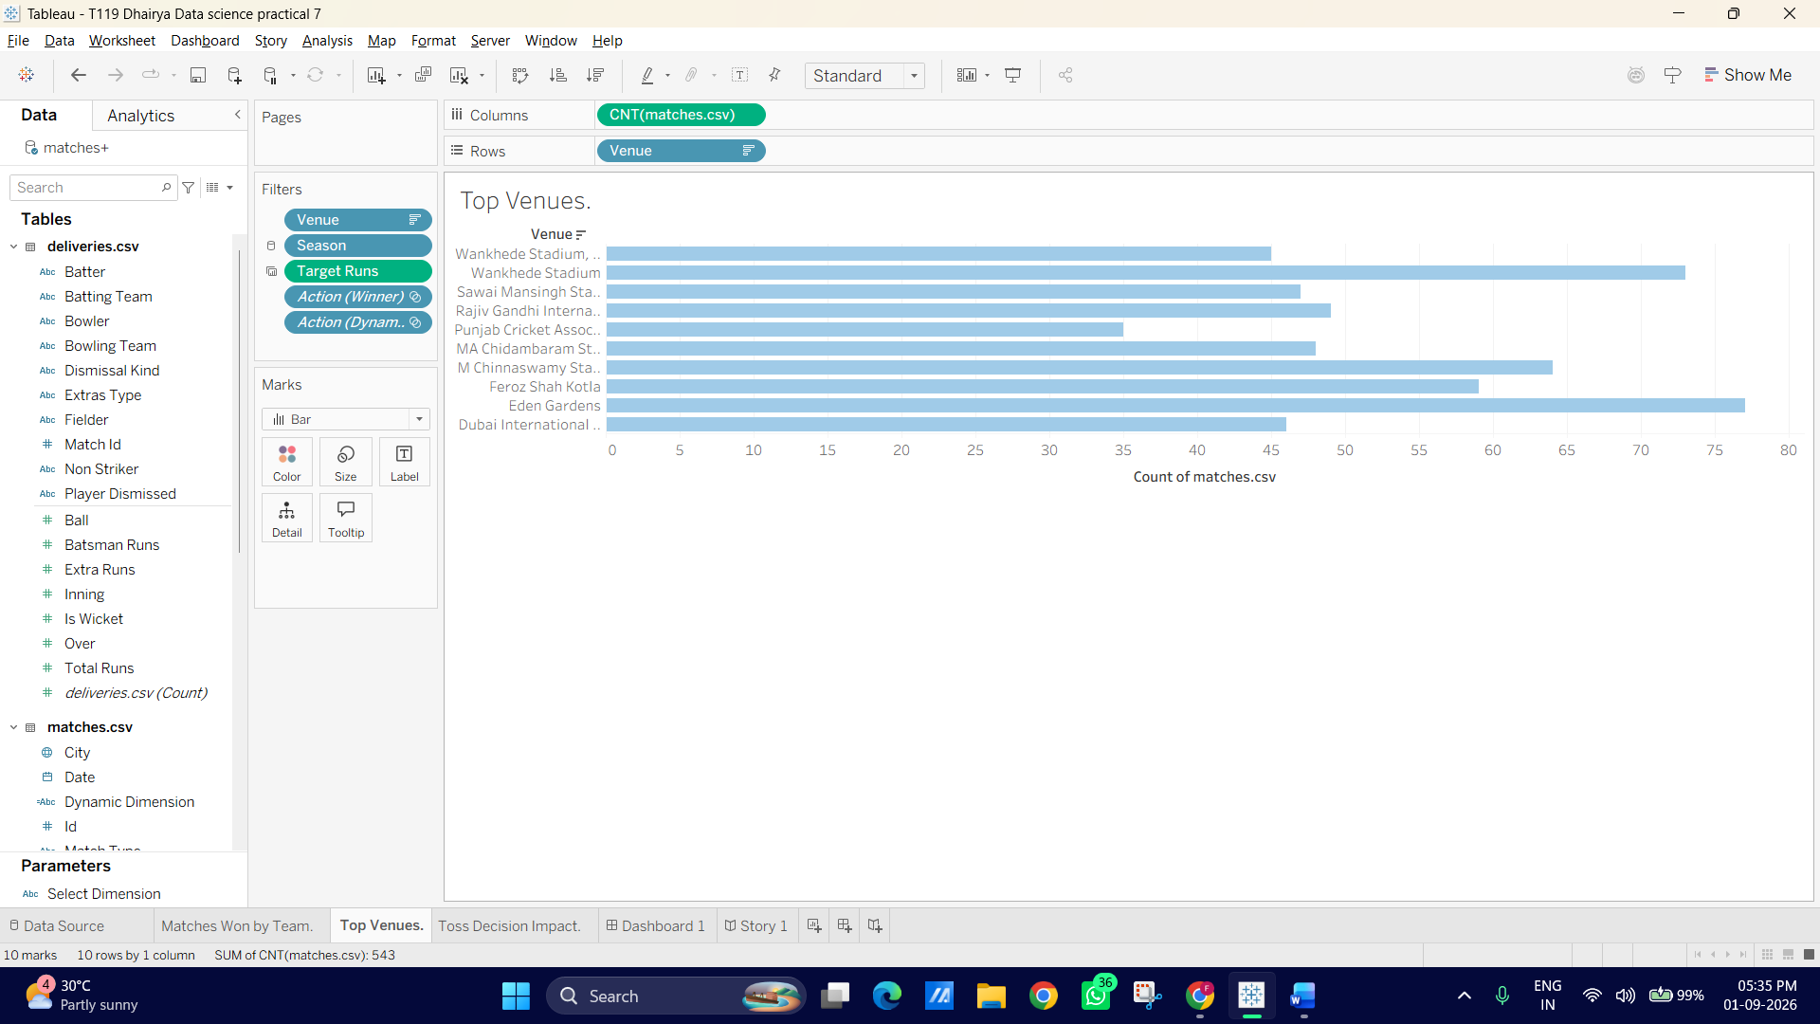

Step 3: Create Sheet 3 "Toss Decision Impact" (Pie Chart or Donut Chart)
1. Open a new worksheet and rename it: Toss Decision Impact.
2. Change the Marks card drop-down from Automatic to Pie
3. Drag Toss Decision (bat/field) to Color on the Marks card.
4. Drag Matches (Count) to Angle on the Marks card.
5. Drag Toss Decision and Matches (Count) to Label on the Marks card.
6. Look at the Marks card on the left side of your chart view.
7. Find the green pill named CNT(Matches) (or CNTD(Id)) that has a small T or Label icon next to it.
8. Right-click directly on that green pill (or click its small drop-down arrow).
9. In the pop-up menu, hover over Quick Table Calculation.
10. Select Percent of Total.
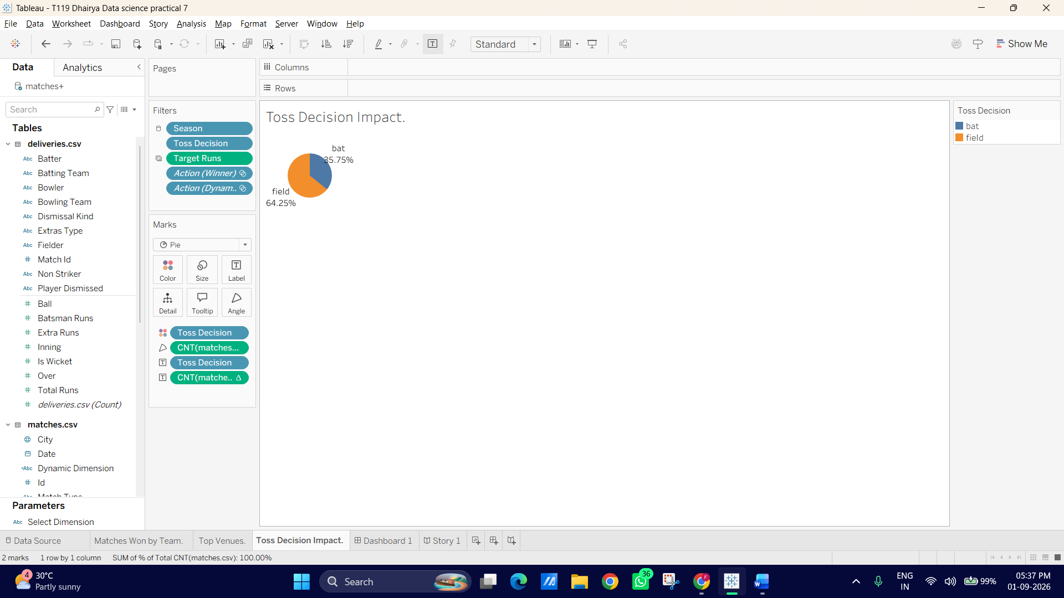

Step 4: Assemble the Dashboard Layout
1. Create a new Dashboard (click the middle icon at the bottom tab area).
2. On the left sidebar under Size, set Fixed Size to Desktop Browser (1000 x 800) or Automatic.
3. Under Objects on the bottom left, ensure Tiled is selected.
4. Drag a Vertical Container into the blank dashboard area.
5. Add a Text object at the top inside the container:
- Header Text: IPL Performance & Match Analysis Dashboard (2008–2024)
- Format: Bold, 18pt, centered
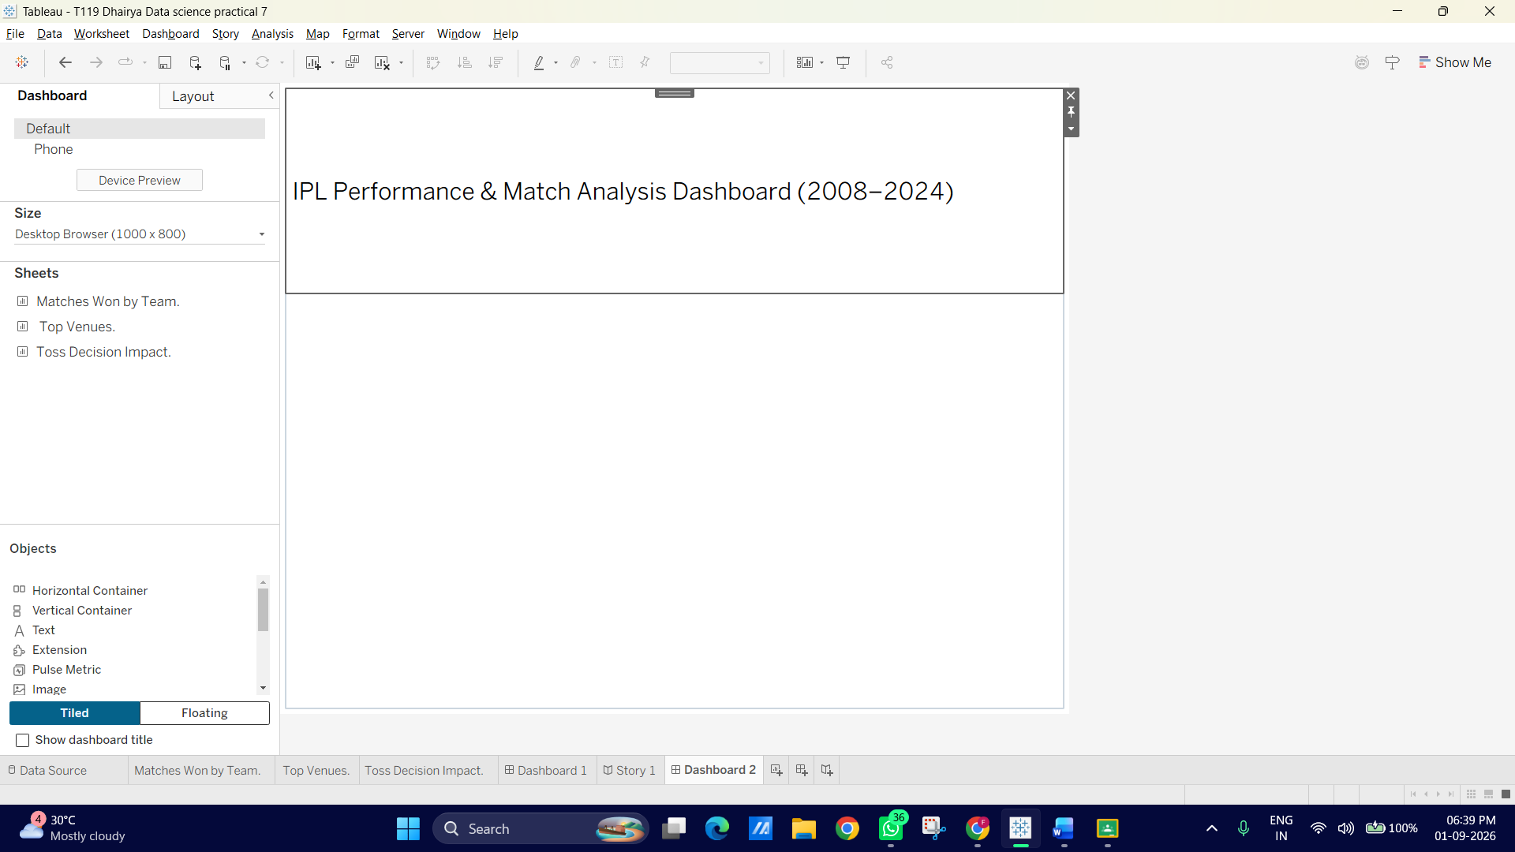
6. Drag your three sheets into the layout:
- Drag Matches Won by Team into the top/left area.
- Drag Top Venues next to or below it.
- Drag Toss Decision Impact to the side panel.
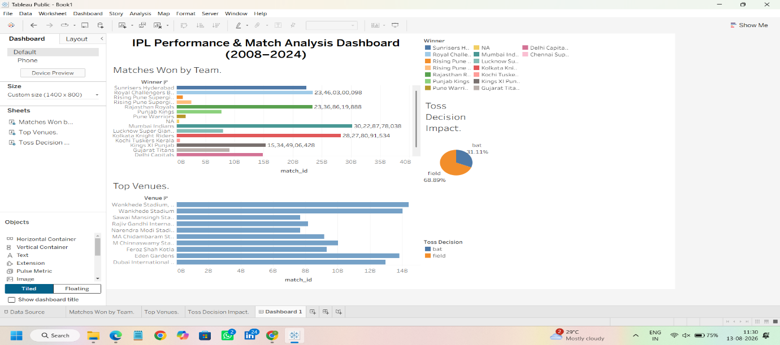

B: Add filters and interactive controls
In this part, we will add interactive controls (dropdowns, range sliders, and single-value selectors) across our dashboard so users can slice and dice the IPL data across seasons, cities, and match types.
Step 1: Add a Season Filter across All Worksheets
1. Go back to your Matches Won by Team worksheet.
2. Drag Season from the Data pane onto the Filters card.
3. Select All and click OK.
4. Right-click the Season pill on the Filters card and select Apply to Worksheets ◊All Using This Data Source
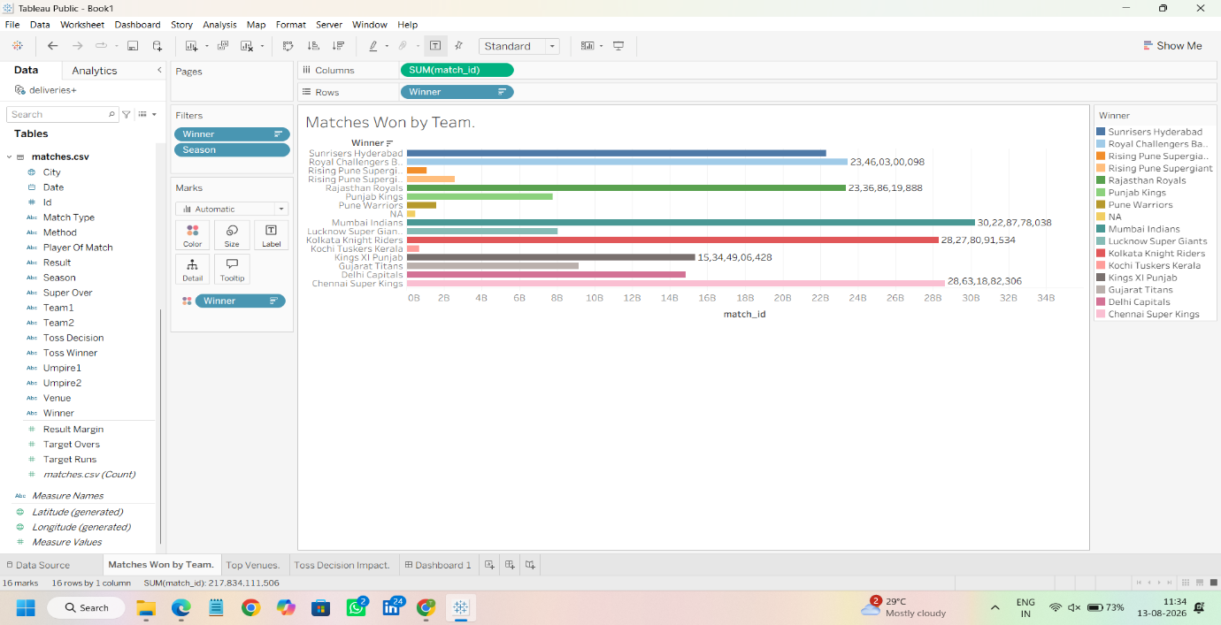
Step 2: Add Filters to the Dashboard View
1. Switch back to your main Dashboard tab.
2. Click on the Matches Won by Team chart box to select it.
3. Click the small More Options drop-down arrow in the top-right corner of the chart outline box.
4. Go to Filters ◊select Season.
5. The Season filter box will appear on your right sidebar.
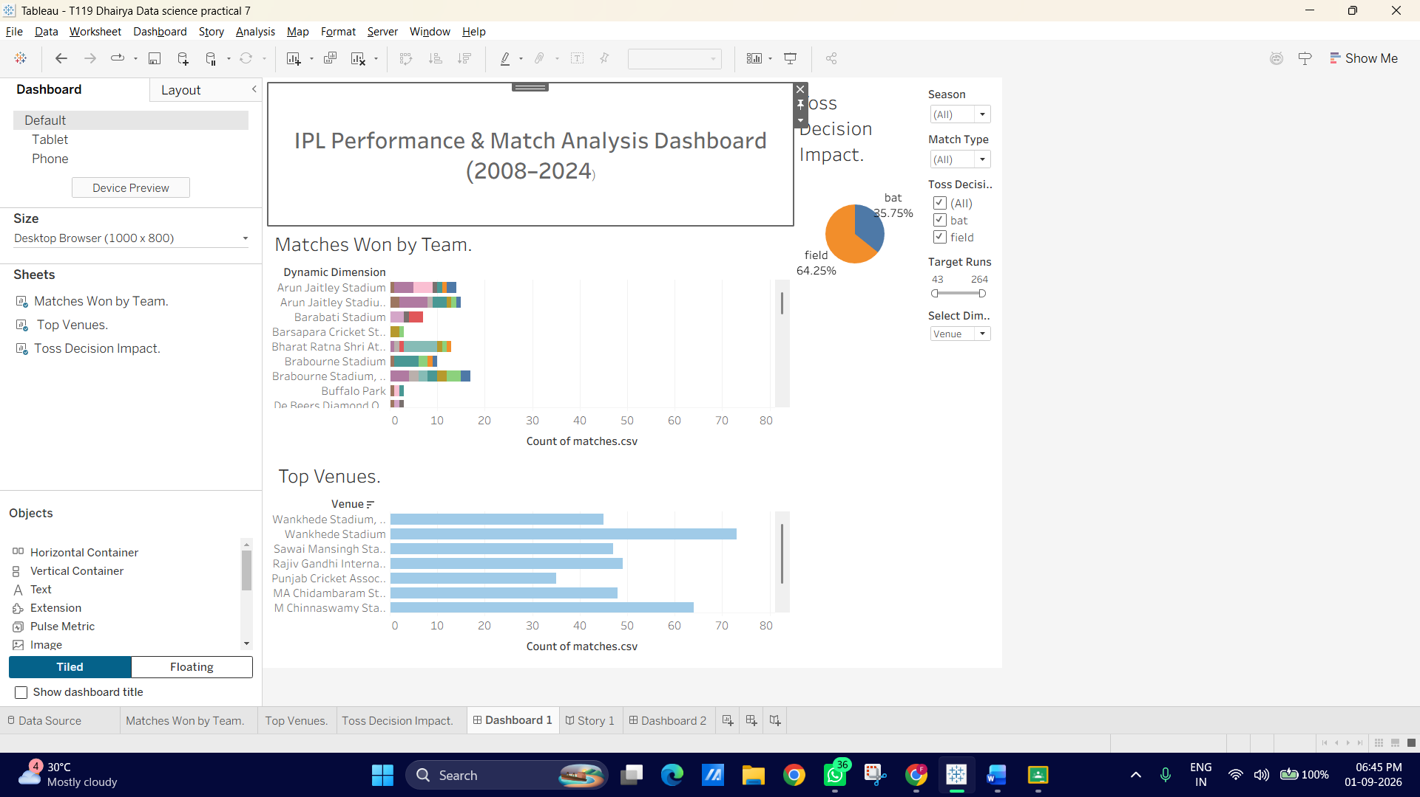
Step 3: Customize Filter Styles for User-Friendly Interactivity
1. Click the drop-down arrow on the top right of the new Season filter container box on your dashboard.
2. Change the filter style to Multiple Values (Dropdown) or Wildcard Match / Single Value List (Dropdown keeps the dashboard clean).
3. Repeat the process to add two more interactive filters:
- Click once anywhere inside your Matches Won By Team bar chart. A gray border will appear around it, indicating it is selected.
- Click the downward-pointing triangle (More Options) located on the top right edge of that gray border.
- Hover over Filters in the menu and select Match Type. (Note: If it is not listed, you will need to navigate back to your "Matches Won By Team" worksheet, drag Match Type to the Filters shelf there, and then return to your dashboard).
- Match Type (Filter by League vs. Playoff / Final matches) - set control type to Single Value (List) or Radio Buttons
- City or Toss Decision - set as a Multiple Values (Dropdown).
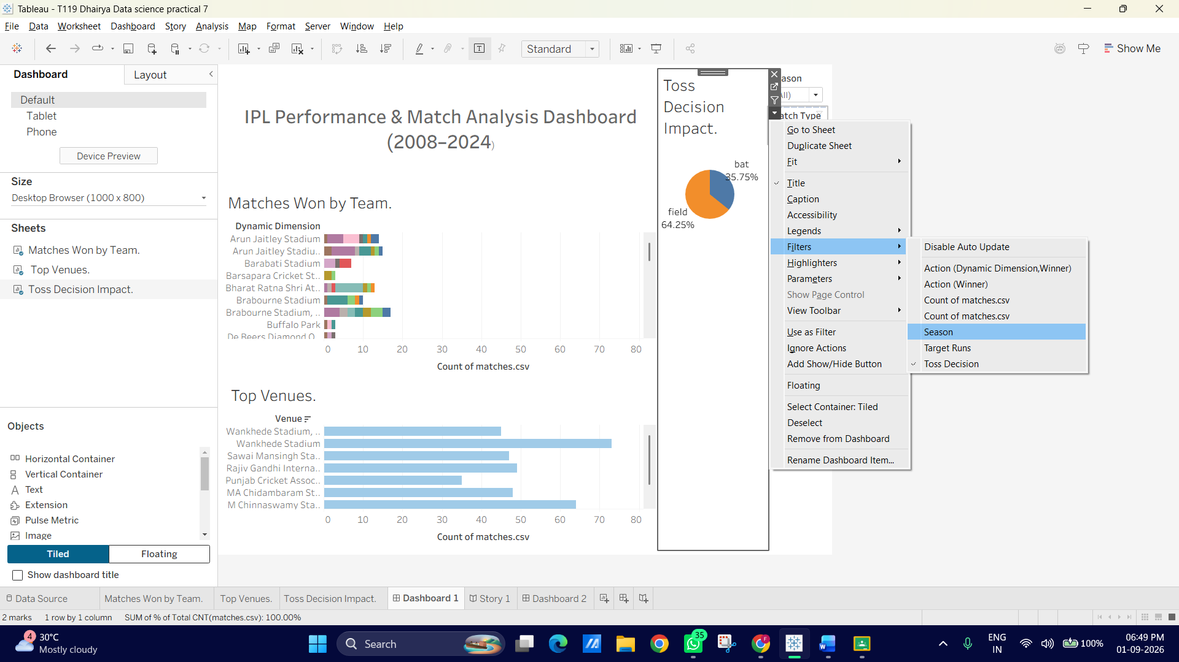
Step 4: Add a Target Runs Range Slider (Interactive Measure Control)
1. Go to the Top Venues sheet.
2. Drag Target Runs to the Filters card.
3. Choose Range of Values and click OK.
4. Right-click the Target Runs filter pill ◊Apply to Worksheets ◊Selected Worksheets (check all 3 dashboard sheets).
5. On the dashboard, enable the Target Runs filter from the chart's options menu.
6. Observe how dragging the range slider dynamically isolates high-scoring vs. lowscoring matches across venues and teams!
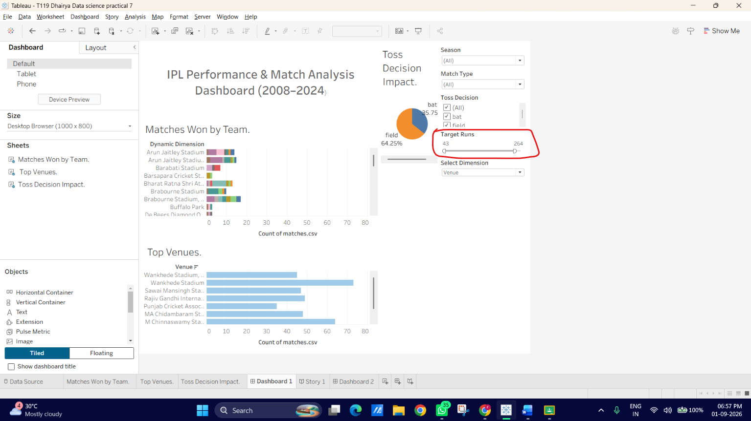

C: Implement highlight and filter actions
In this part, we will configure dashboard actions so that clicking on a specific team, venue, or pie slice automatically filters or highlights related details across all other sheets on your dashboard.
Step 1: Use a Sheet as a Quick Filter (The Easy Method) Tableau provides a 1-click way to turn any chart into an interactive filter for the entire dashboard:
1. Click on the Matches Won by Team chart box on your dashboard to select it.
2. Look at the small vertical toolbar that pops up on the top right side of the sheet border.
3. Click the Use as Filter icon (it looks like a small funnel symbol).
4. Test it: Click on Chennai Super Kings or Mumbai Indians in the bar chart. You will see both the Top Venues chart and the Toss Decision Impact pie chart dynamically update to show data only for that selected team! Click the selected bar again to clear the filter.
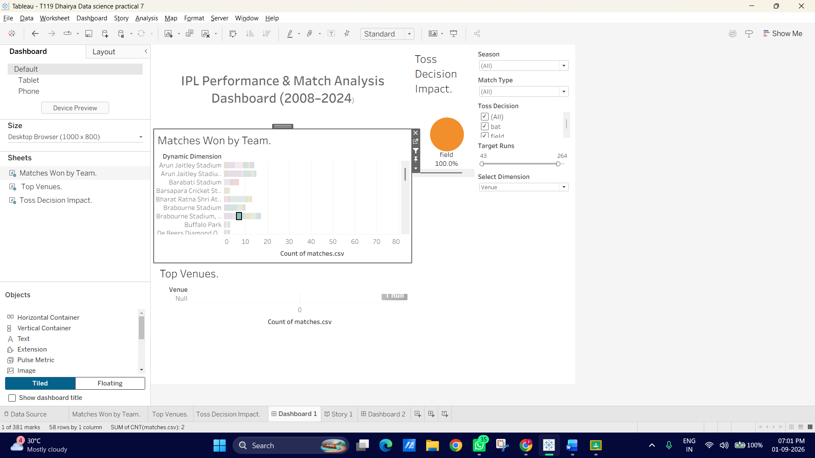
Step 2: Set Up an Explicit Highlight Action via the Dashboard Menu
Next, let's create a dedicated Highlight Action using Tableau's main Action Manager:
1. On the top menu bar, go to Dashboard --> Actions...
2. In the Actions window, click Add Action > and choose Highlight...
3. Name the action: Highlight Team Across Charts.
4. Set up the rules:
- Source Sheets: Select Matches Won by Team.
- Run action on: Select Hover (or Select if you prefer clicking).
- Target Sheets: Select Top Venues and Toss Decision Impact.
- Target Fields: Leave as All Fields or explicitly select Winner / Team1.
5. Click OK, then click OK again to save.
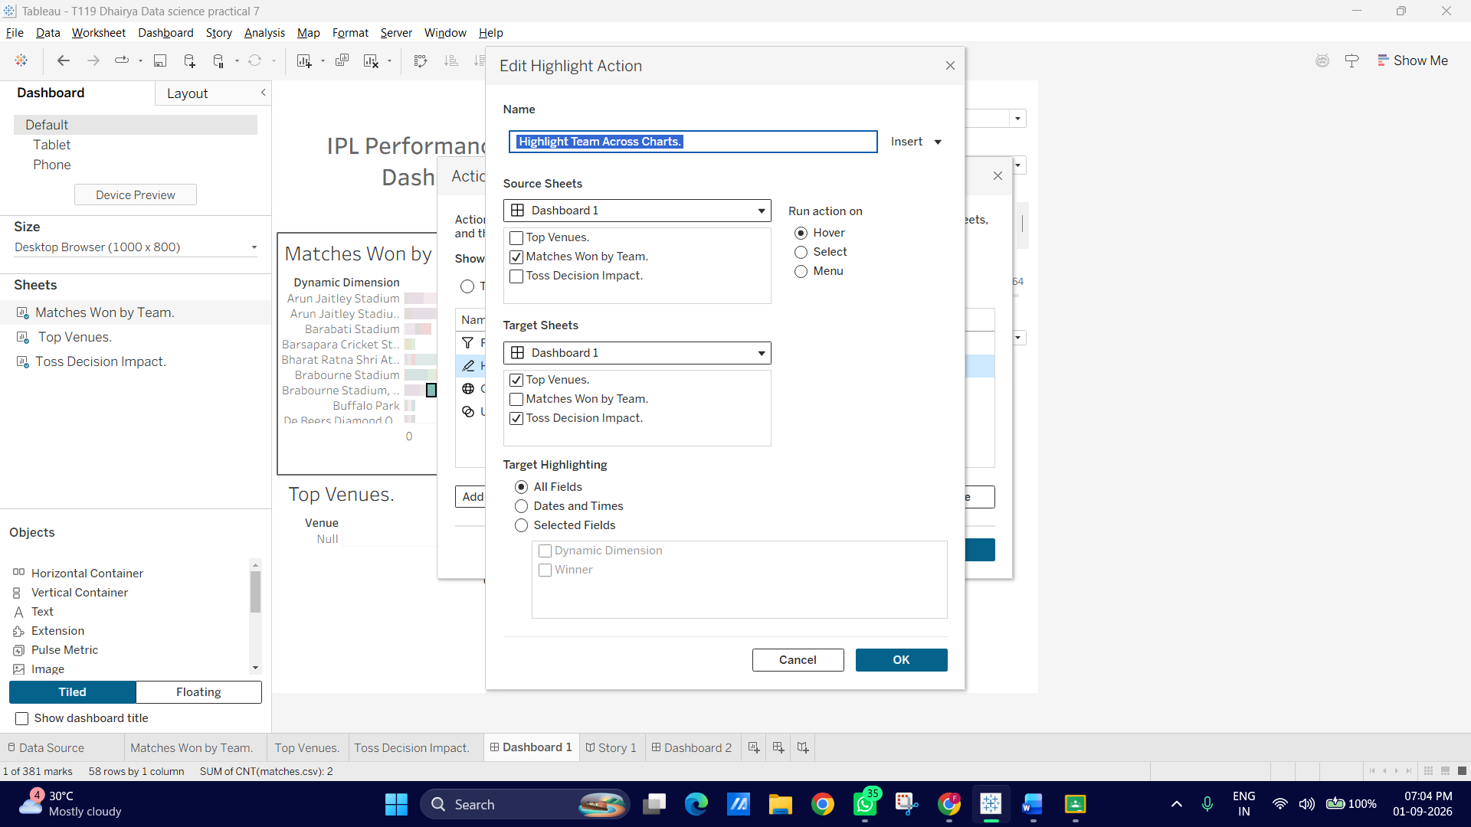
Step 3: Test Your Actions
• Hovering: Hover your mouse over any bar in Matches Won by Team to see associated data highlight across other sheets.
• Clicking: Click a venue in Top Venues (if "Use as Filter" is enabled there too) to see which teams have won the most matches at that specific stadium!
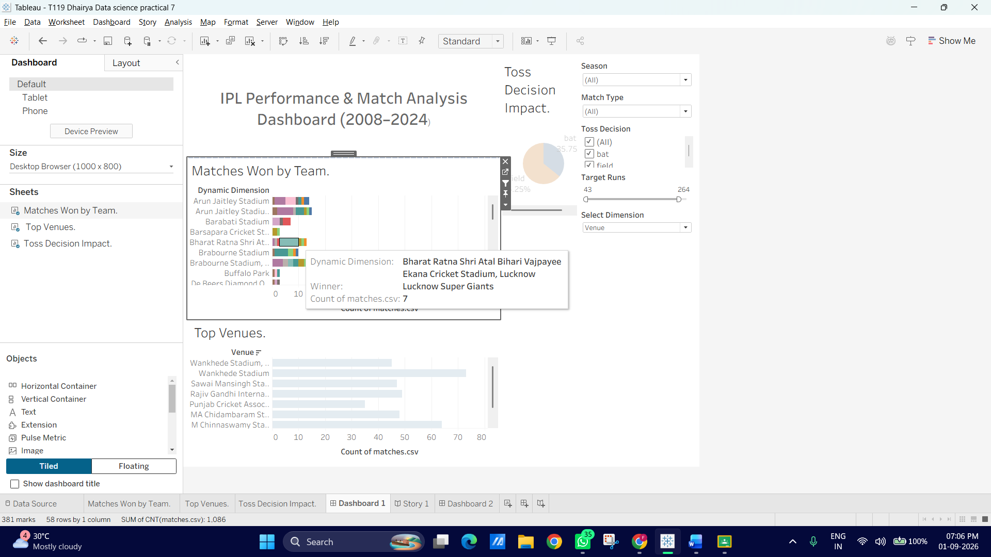

D: Use URL and set actions for interactivity
This is where we add advanced interactivity:
1. URL Action: Clicking a team or player name opens their official Wikipedia/ESPNcricinfo profile directly in a browser (or Web Page Object inside Tableau).
2. Set Action: Selecting one or more teams on a sheet dynamically updates a "Selected vs. Rest of League" comparison.
Task 1: Create a Set Action (Dynamic Team Comparison)
First, let's create a Set and configure a Set Action so clicking a team highlight or isolates that team against the rest of the league.
1. Create the Set in Tableau:
1. Go to the Data pane on the left side of any worksheet.
2. Right-click the Winner field ◊ Create ◊Set...
3. Name the set: Selected Teams Set. 4. Select any single team (e.g., Mumbai Indians) just as a temporary placeholder.
5. click OK.
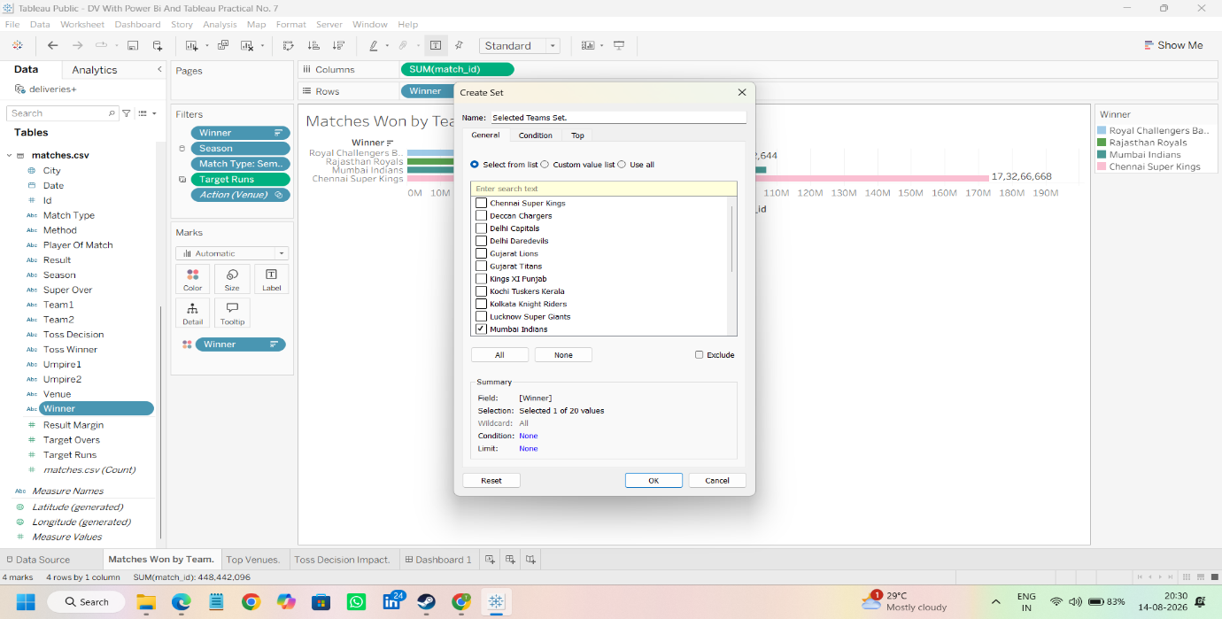

2. Configure the Set Action on the Dashboard:
1. Return to your main Dashboard tab.
2. Go to the top menu bar: Dashboard ◊Actions...
3. Click Add Action > ◊ select Change Set Values...
4. Set up the details:
- Name: Update Selected Team Set
- Source Sheets: Select Matches Won by Teamo Run action on: Select
- Target Dataset: Choose your IPL dataset/matches file.
- Set: Choose Selected Teams Set.
- Running the action will: Assign values to set
- Clearing the selection will: Remove all values from set (or Keep set values).
5. Click OK, then click OK again.
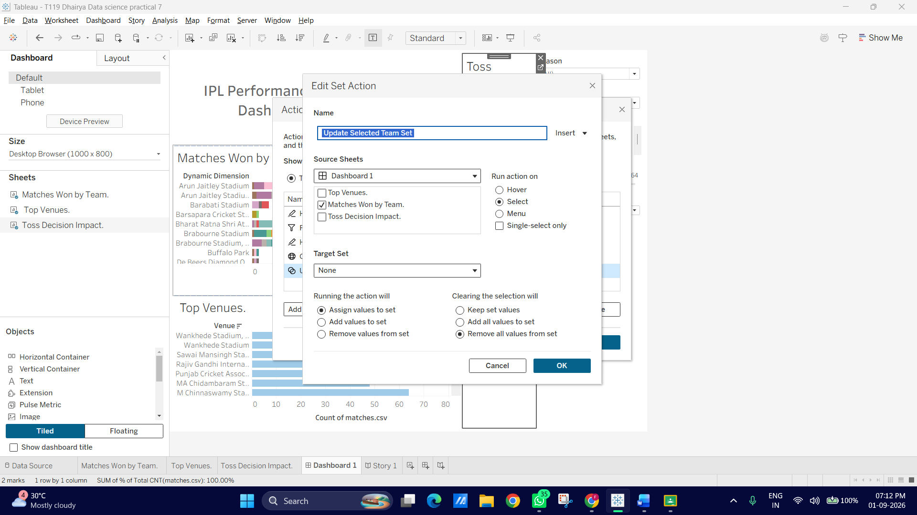

Task 2: Create a URL Action (External Link to Wikipedia / ESPNcricinfo)
Now let's configure an action where clicking a team in your bar chart opens its Wikipedia page automatically.
1. Add the Dashboard Action:
1. Go to the top menu: Dashboard ◊ Actions...
2. Click Add Action > ◊select Go to URL...
3. Configure the URL Action:
- Name: Open Team Wikipedia Page
- Source Sheets: Select Matches Won by Team
- Run action on: Menu (This displays a clean clickable hyperlink inside the tooltip when a user clicks a bar, preventing accidental page loads).
- URL: Paste the following dynamic URL: https://en.wikipedia.org/wiki/
4. Click OK, then click OK again
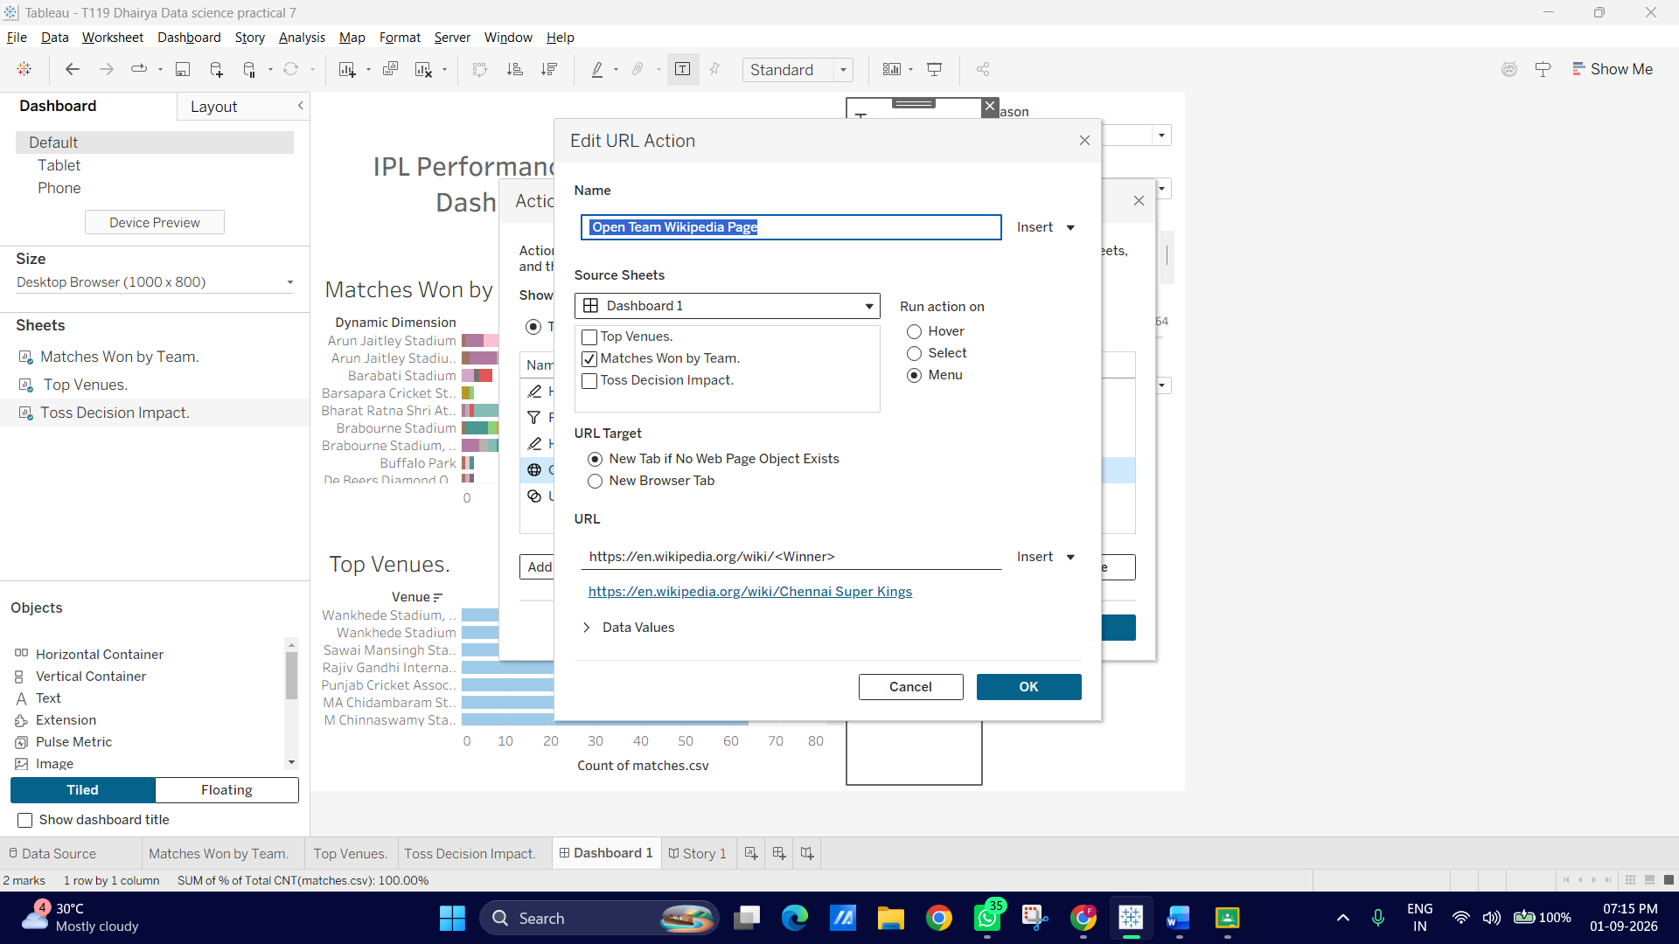
E: Create dynamic dashboards using parameters
Parameters allow users to control what dimensions or measures are shown on a chart. Instead of creating separate sheets for "Wins by Season," "Wins by City," or "Wins by Toss Decision," we will create a single dynamic chart where the user can swap dimensions on the fly using a Parameter
Step 1: Create a Parameter for Dimension Swapping
1. Go to any worksheet (e.g., Matches Won by Team).
2. At the top of the Data pane on the left, click the small drop-down arrow next to the search bar (or right-click anywhere in the Data pane) and select Create Parameter...

3. Configure the parameter options:
- Name: Select Dimension
- Data type: String
- Allowable values: List
- List of values: Add the following exact names in the Value column: ♣ Winner ♣ City ♣ Toss Winner ♣ Venue
4. Click OK.
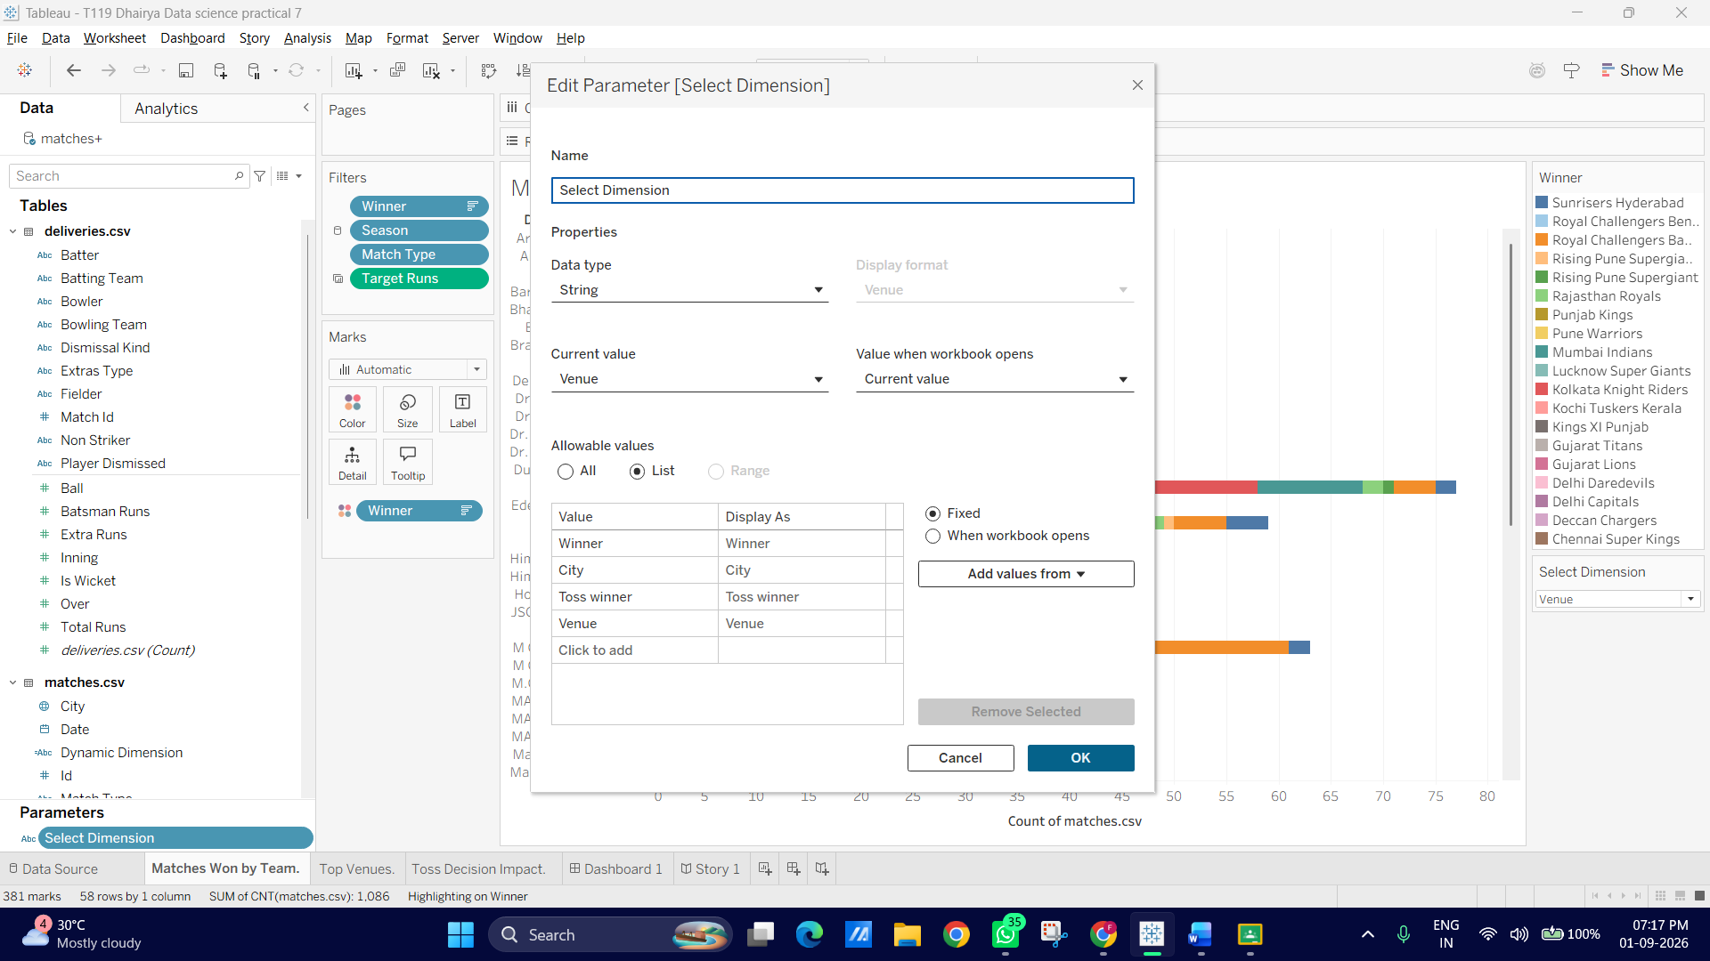
Step 2: Create a Calculated Field to Link the Parameter
A parameter doesn't do anything on its own, we need a calculated field to tell Tableau how to respond when the parameter value changes.
1. Right-click in the Data pane ◊ Create Calculated Field...
2. Name the field: Dynamic Dimension
3. Enter the following formula:
CASE [Select Dimension]
WHEN 'Winner' THEN [Winner]
WHEN 'City' THEN [City]
WHEN 'Toss Winner' THEN [Toss Winner]
WHEN 'Venue' THEN [Venue] END
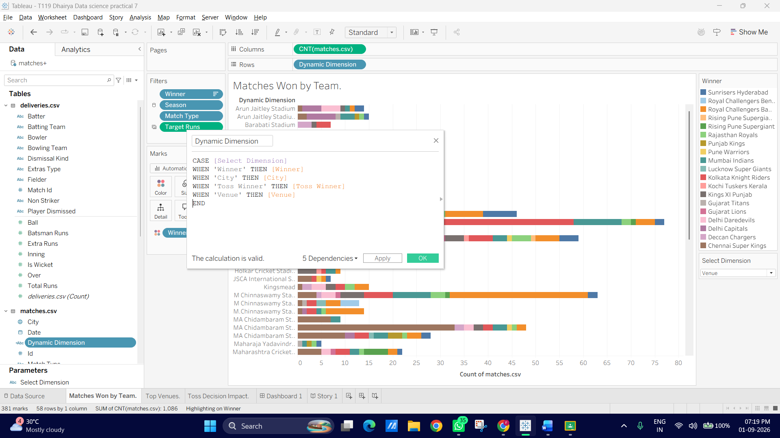
Step 3: Replace the Fixed Field with the Dynamic Field
1. On your Matches Won by Team sheet, locate the field currently on the Rows shelf (e.g., Winner).
2. Drag Dynamic Dimension from the Data pane and drop it directly over Winner on the Rows shelf to swap them.
3. In the Data pane under Parameters, right-click Select Dimension and check Show Parameter.
4. Test changing the parameter selection on the right panel, you'll see the chart instantly switch between listing Teams, Cities, Toss Winners, and Venues!
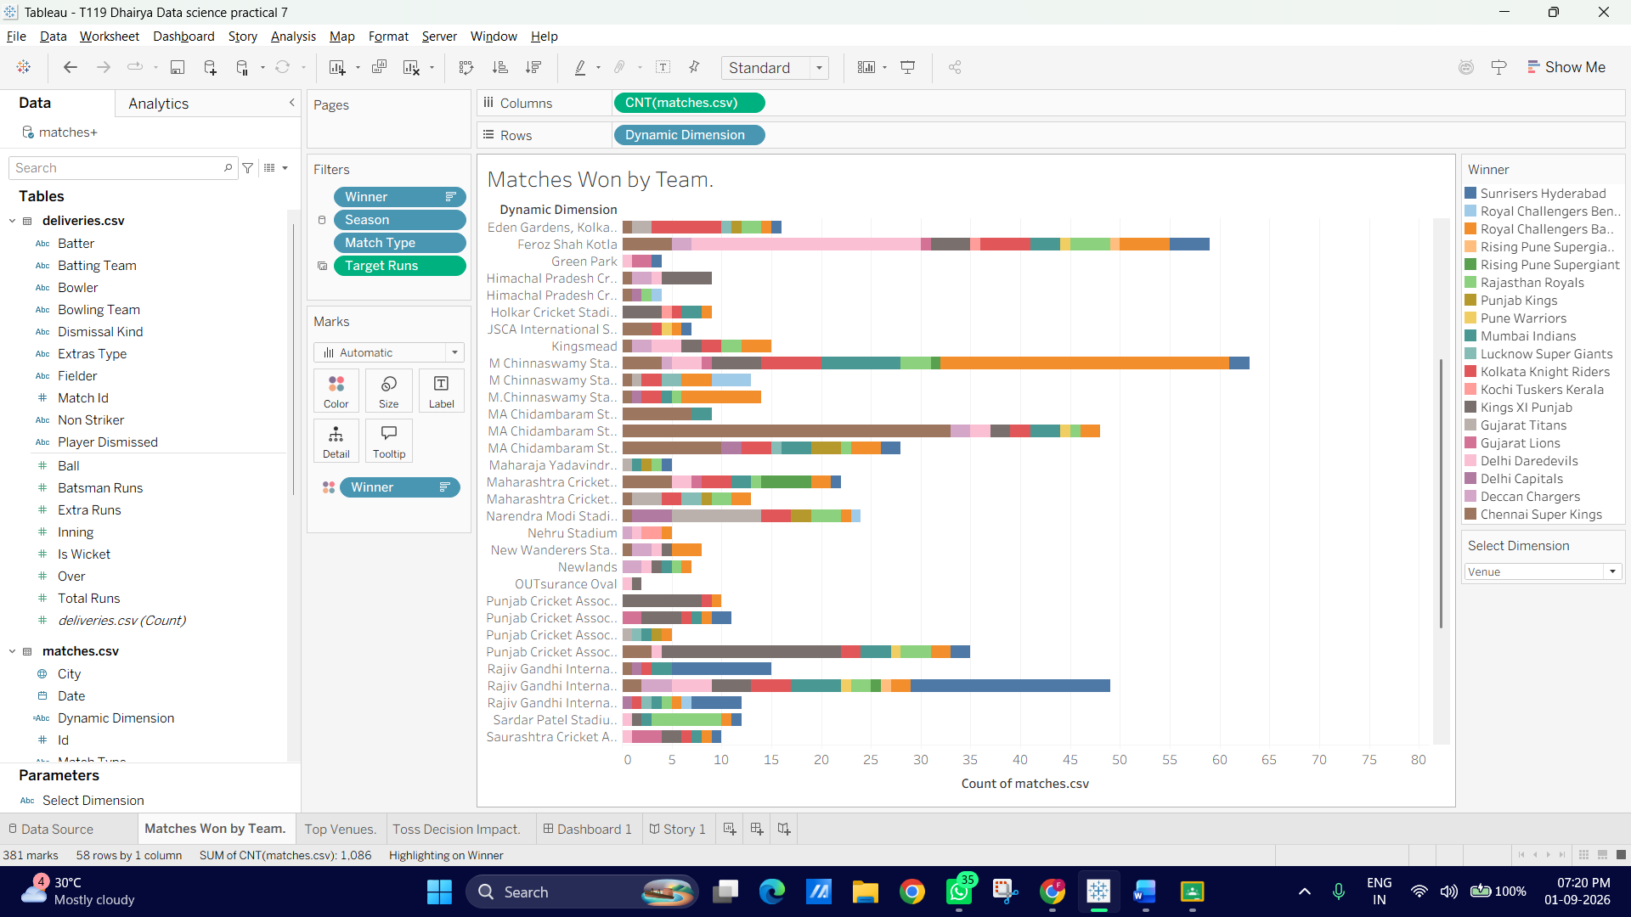
Step 4: Display the Parameter Control on the Dashboard
1. Switch back to your main Dashboard tab.
2. Select the dynamic chart box.
3. Click the More Options drop-down arrow in the top right corner of the chart outline box.
4. Go to Parameters ◊select Select Dimension.
5. Position the new parameter control cleanly alongside your existing filters on the right sidebar.
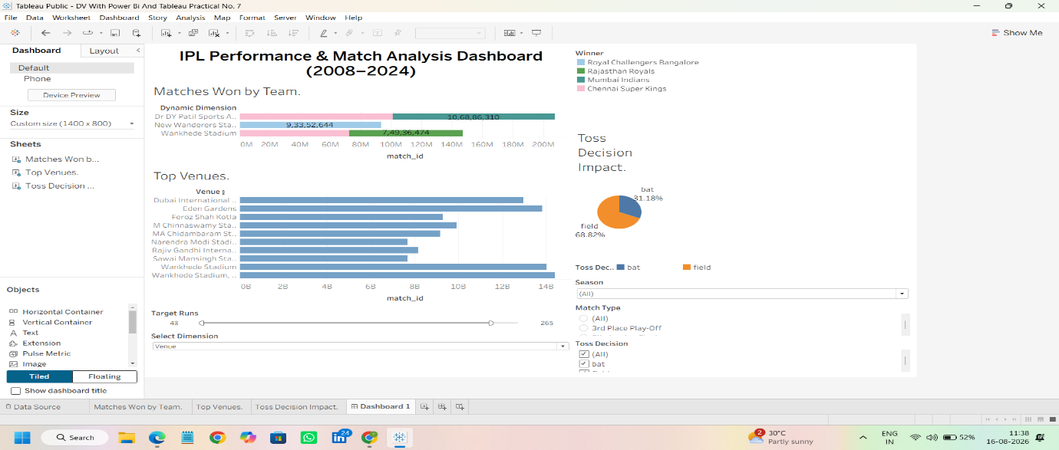

F: Design dashboards for multiple devices
In this part, we will use Tableau's Device Designer to ensure your IPL Dashboard automatically adapts its layout when viewed on a Desktop, Tablet, or Mobile Phone.
Step 1: Open the Device Designer Panel
1. Switch to your main Dashboard tab.
2. In the top-left Dashboard pane, click the Device Preview button.
3. A device preview frame and toolbar will appear across the top of your dashboard canvas, showing how your layout looks on different screens.
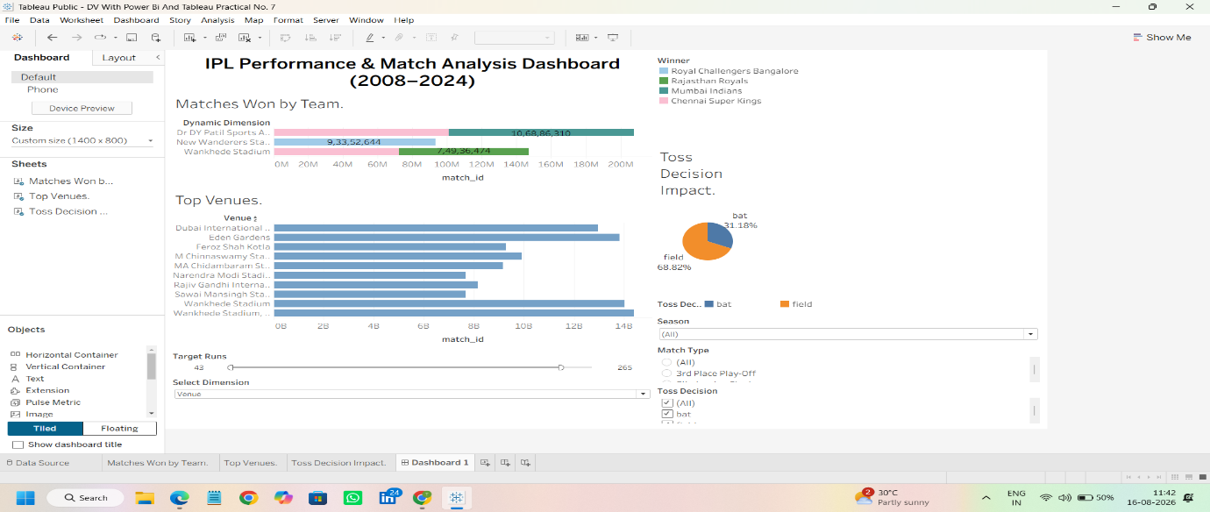
Step 2: Add a Phone Layout
1. In the top device preview bar, select Device type: ◊Phone.
2. Click the Add Phone Layout button on the right side of the preview bar.
3. You will now see a new sub-tab named Phone appear under the Dashboard panel on the left.
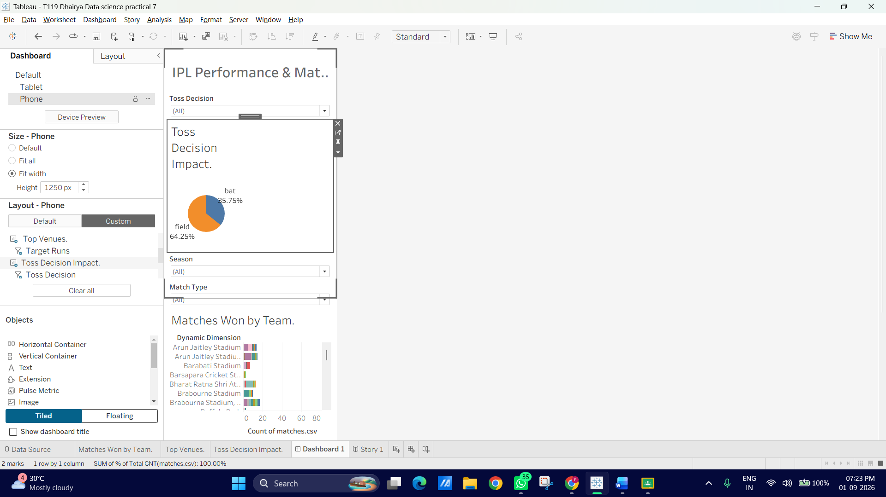
Step 3: Customize the Phone Layout for Vertical Scrolling
Mobile screens require a vertical stack rather than side-by-side tiled views:
1. In the left panel under the Phone layout section, change Layout from Default to Custom (this allows you to edit the phone layout without affecting your desktop view).
2. Tableau will automatically generate a single-column stack. Arrange the items vertically in logical order: o Title & Global Filters (Season, Dynamic Dimension parameter) at the top. o Matches Won by Team (Primary high-level chart). o Top Venues chart below it. o Toss Decision Impact pie chart at the bottom.
3. Hide secondary elements if needed: Right-click any non-essential filter or legend container in the phone tree view and select Remove from Layout (this removes it only from the phone screen, keeping your mobile dashboard clean and clutter-free).
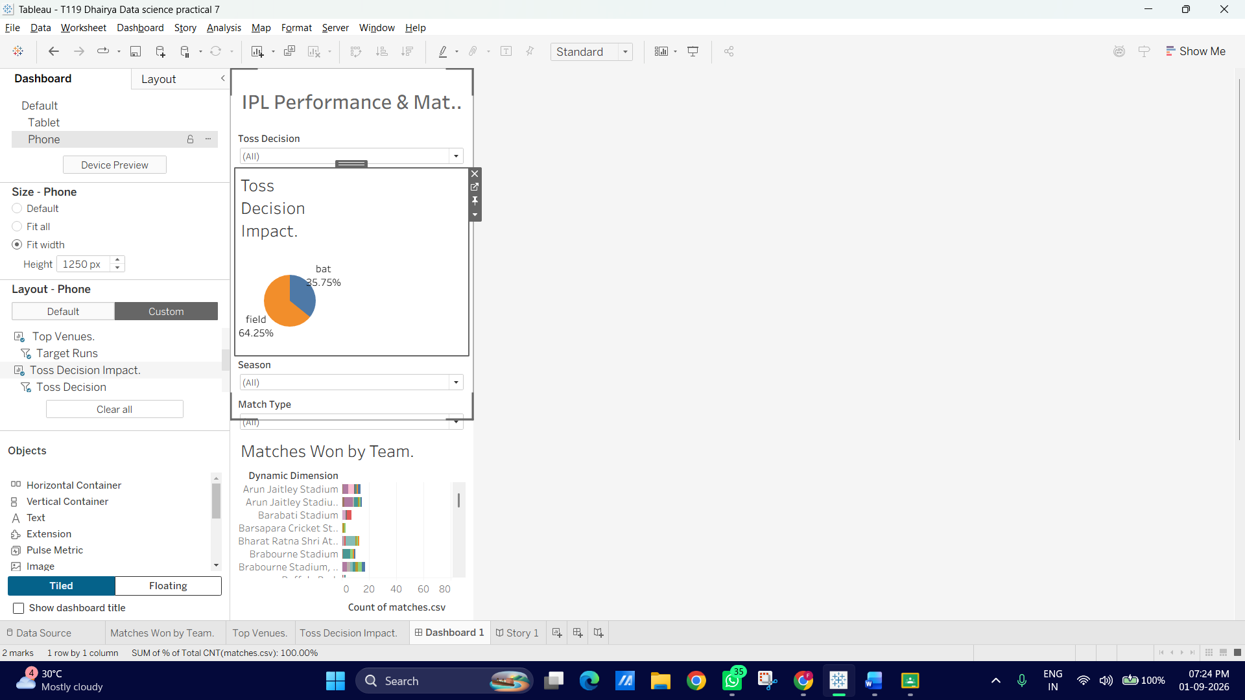
G: Build a complete data story using Story feature
Step 1: Create a New Story Workspace
1. At the bottom of your Tableau workspace (where your Sheet and Dashboard tabs are), click the New Story tab icon (the notebook icon with a plus sign at the far right).
2. Double-click the title heading at the top of the canvas and rename your story to: IPL Performance & Strategy: Data Story
3. Set the Story size in the left sidebar under Size to Automatic or Caption Style so it fits your screen nicely.
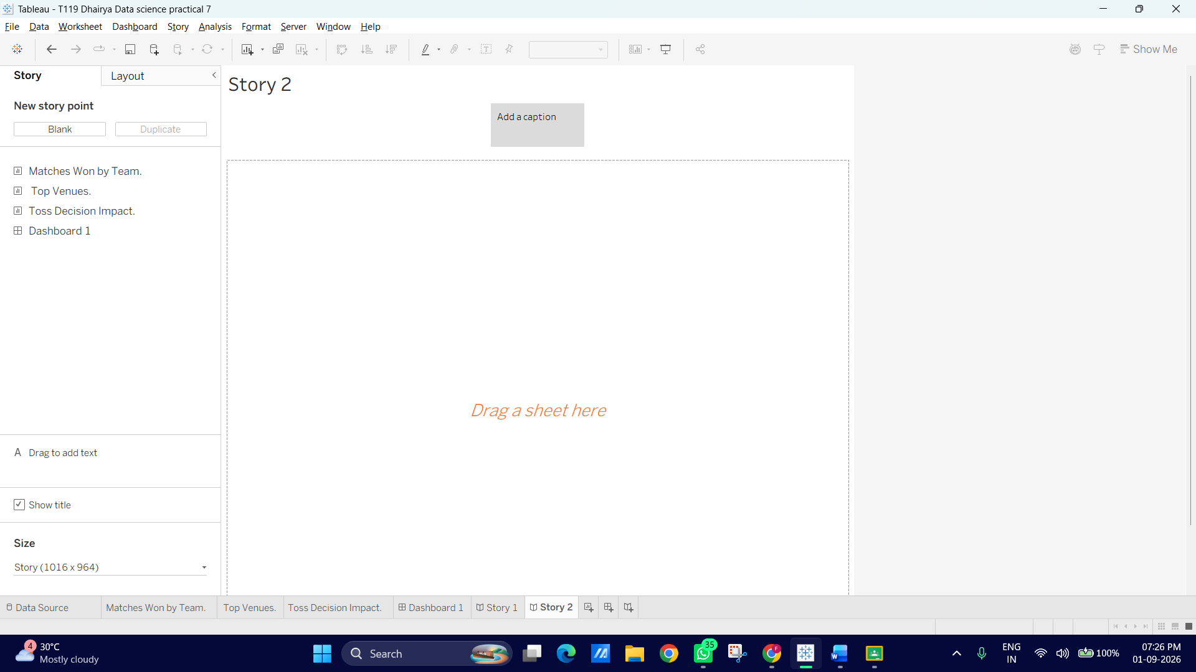
Step 2: Story Point 1 — Macro League Overview
1. From the left Story pane, drag your main IPL Dashboard onto the blank canvas.
2. Click inside the grey caption box above the dashboard slide (labeled "Write description text here") and type: 1. League Performance Overview
3. On this slide, keep your filters set to All Seasons so it serves as an high-level executive summary of team wins and total match dynamics across the IPL.
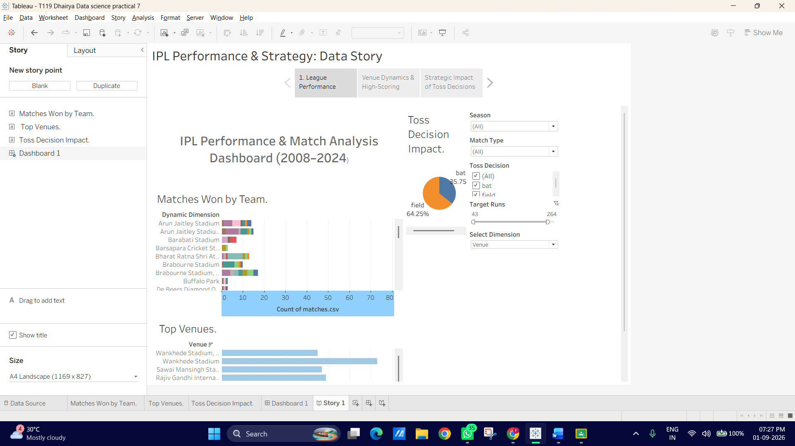

Step 3: Story Point 2 — Venue Analysis & Scoring Trends
1. Click Blank under the New Story Point section on the left sidebar to add a second slide.
2. Drag your IPL Dashboard onto the canvas again.
3. In this slide, use your new Select Dimension parameter dropdown to change the primary chart view to Venue, and set your Target Runs slider to focus on high-scoring matches (180+ runs).
4. Update the top caption box for this point to: 2. Venue Dynamics & High-Scoring Grounds
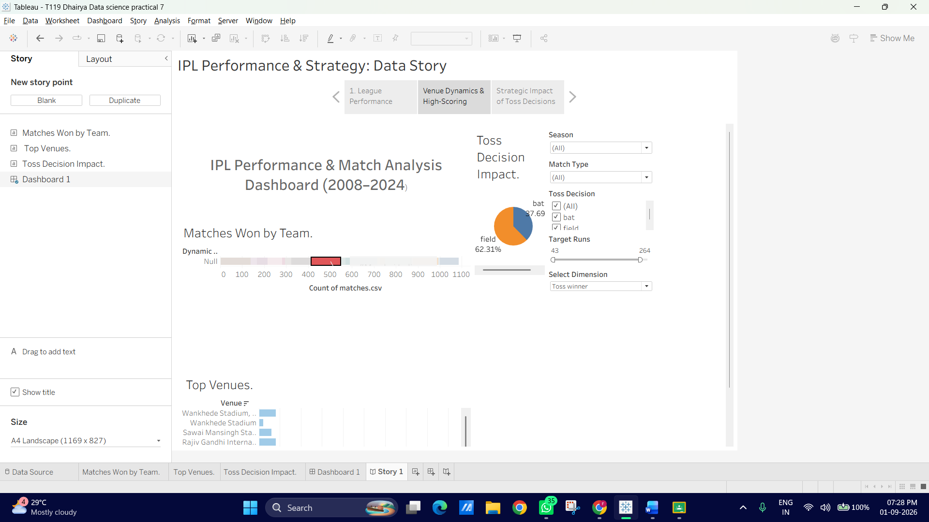
Step 4: Story Point 3 — The Impact of the Toss
1. Click Blank to add a third story point.
2. Drag the Toss Decision Impact worksheet (or the full dashboard) onto this slide.
3. Use the Season or City filter controls to highlight how winning the toss and choosing to bat vs. field impacts match outcomes in specific conditions.
4. Update the caption to: 3. Strategic Impact of Toss Decisions
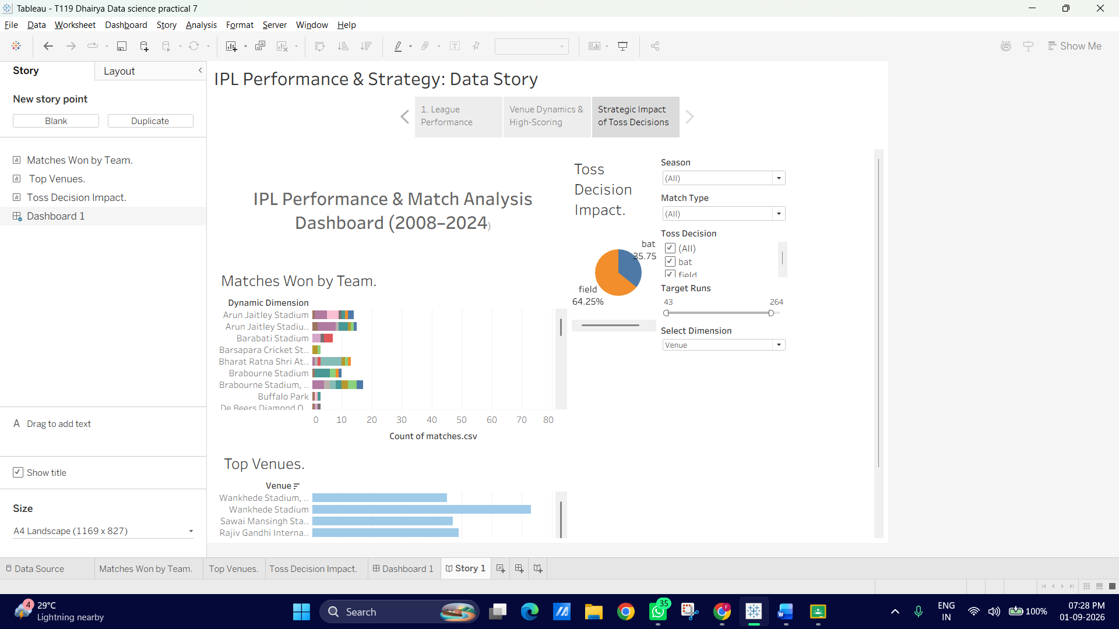
Step 5: Add Callout Annotations for Key Takeaways
To make your story presentation self-explanatory for stakeholders:
1. Go to Story Point 1 or Story Point 2.
2. Right-click a notable mark (e.g., the top team bar for Mumbai Indians or M. Chinnaswamy Stadium).
3. Select Annotate --> Mark... (or Point...).
4. Enter a succinct takeaway (e.g., "Mumbai Indians lead total match wins across seasons").
5. Drag the callout text box to place it clearly beside the visual element.
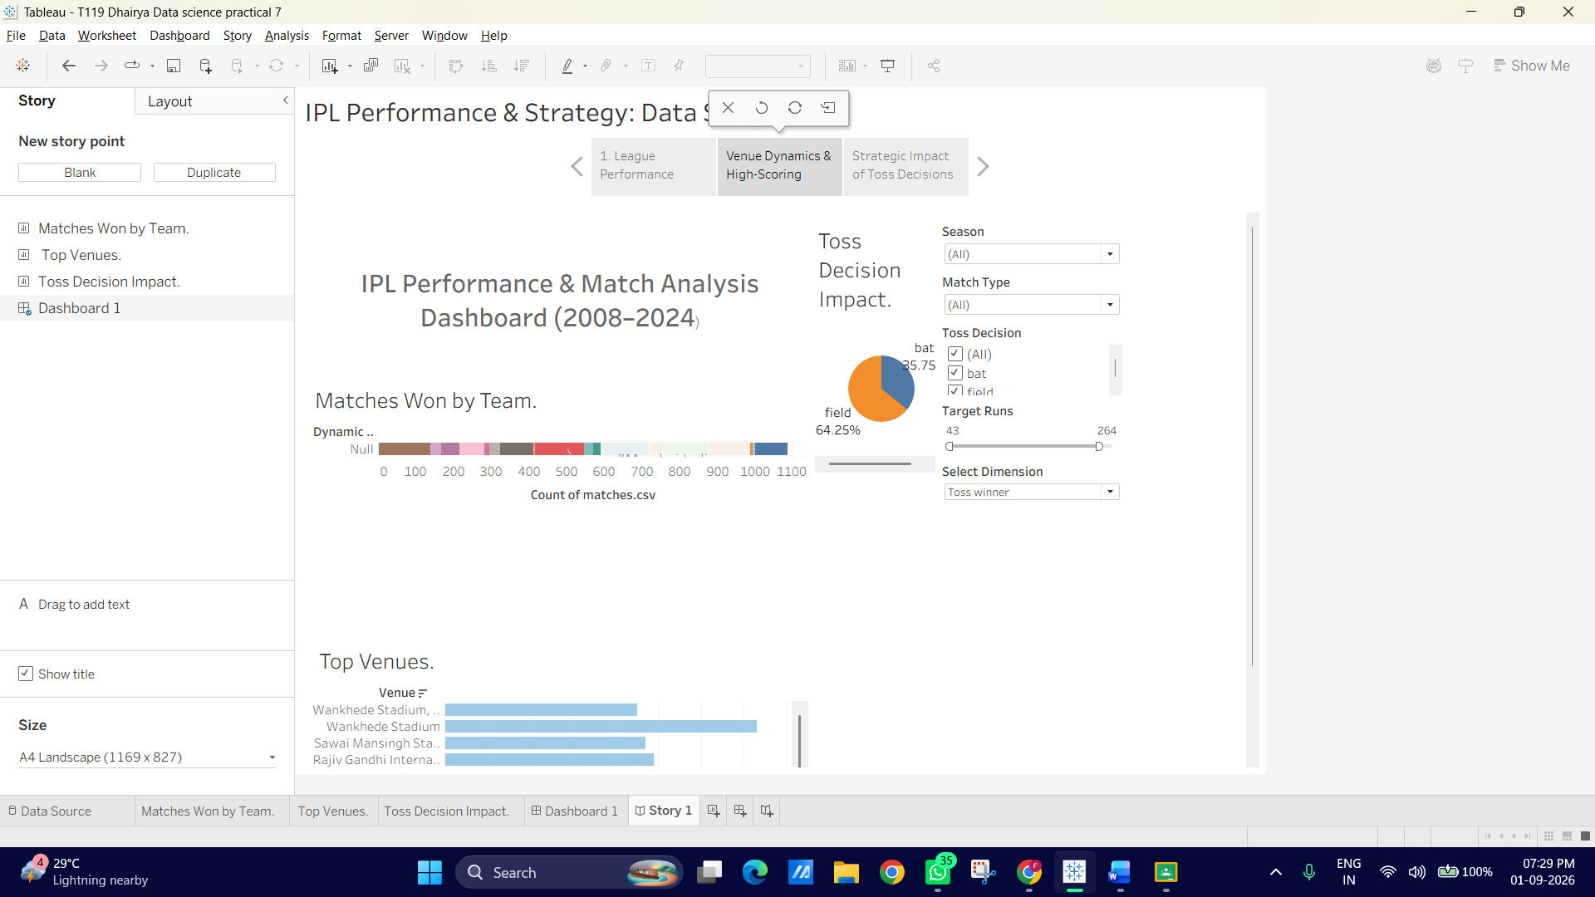
Step 6: Presentation Mode Walkthrough
1. Press F5 (or click the Presentation Mode icon in the top toolbar) to view your story full-screen.
2. Click through the story navigator buttons at the top to ensure each slide maintains its customized filter state and annotations while preserving full interactivity
